
Activate Windows Server OS with Azure KMS
2/10/2021

Cognizant Microsoft Business Group
20 North Wacker Drive #530
Chicago, IL 60606

Notice of Confidentiality ©2021 Cognizant Microsoft Business Group All rights reserved.

IS SUBJECT TO THE TERMS OF THE COGNIZANT MICROSOFT BUSINESS GROUP NON-DISCLOSURE AGREEMENT. NEITHER THIS DOCUMENT NOR ITS CONTENTS MAY BE REVEALED OR DISCLOSED TO UNAUTHORIZED PERSONS OR SENT OUTSIDE THE AFOREMENTIONED COMPANY WITHOUT PRIOR PERMISSION FROM COGNIZANT MICROSOFT BUSINESS GROUP

Table of Contents
Summary 3
WIndows Activation 3

Summary
This document is intended to describe the activation of a Windows Server, post migration, In the event that it does not activate automatically or Is not pointed to the Azure Key Management Server.

WIndows Activation
Below are source(s) that will be used to assist in activating the server that has been recently migrated:
[1] https://docs.microsoft.com/en-us/previous-versions/windows/it-pro/windows-server-2012-R2-and-2012/jj612867(v=ws.11)?redirectedfrom=MSDN
[2] https://docs.microsoft.com/en-us/azure/virtual-machines/troubleshooting/troubleshoot-activation-problems

- Open Command Prompt by navigating to the Start menu and type “Command Prompt”
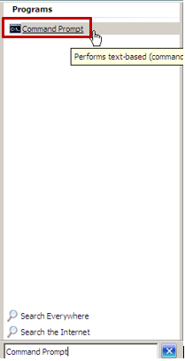
- In the command prompt window, type in the following command to install a product key:
cscript c:\windows\system32\slmgr.vbs /ipk <KMS client setup key>
  - You can find the <KMS client set up key> in the referenced document [1] above by searching for the OS version of the server that requires activation.
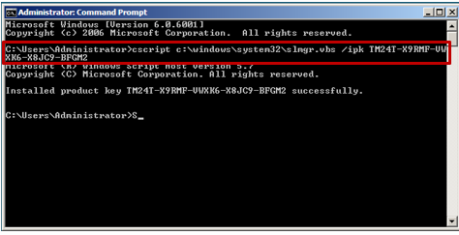
- After the product key has been installed, run the following command to activate the product key:
cscript c:\windows\system32\slmgr.vbs /ato

- Once the product key has been activated, you can now point the server to the Azure Key Management Server – to do this, run the following command:
Cscript C:\Windows\System32\slmgr.vbs /skms kms.core.windows.net:1688
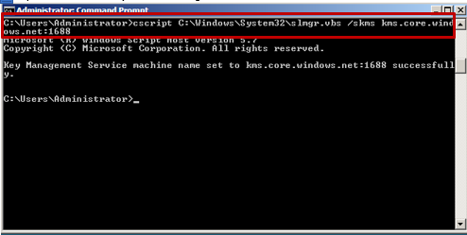

- After you have completed the activation, continue with post migration configuration, as needed.

